**Privacy Tools**

**Cyber Intel**

# Executive Summary

The report provides an overview of PrivacyTools, a comprehensive online resource dedicated to empowering individuals with knowledge and tools to protect their digital privacy. The platform offers a curated collection of privacy-focused services, software recommendations, and educational content on various aspects of online privacy.

PrivacyTools serves as a centralized hub for individuals concerned about surveillance, data breaches, and invasive tracking practices. It provides valuable resources such as guides, tutorials, reviews, and comparisons to help users make informed choices in safeguarding their personal data.

While the platform covers a wide range of topics including web browsing, email providers, messaging apps, VPNs (Virtual Private Networks), password managers, encryption techniques, etc., it does not guarantee absolute security or anonymity. Users are encouraged to carefully evaluate the recommended options based on their unique circumstances.

# Index

**Executive Summary 2**

**Index 2**

**1. Introduction 2**

**2. Tool Details 2**

**3. Installation 3**

**4. Execution 3**

**5. Scope and Limitations 3**

**6. Conclusion 3**

**7. References (if any) 4**

# Introduction

PrivacyTools is a comprehensive online resource that aims to empower individuals with the knowledge and tools to protect their digital privacy. With growing concerns about surveillance, data breaches, and invasive tracking practices, PrivacyTools offers a curated collection of privacy-focused services, software recommendations, and guides on various aspects of online privacy. Whether you are an average internet user or a tech-savvy individual looking for reliable information on protecting your personal data, PrivacyTools serves as an invaluable platform to help you reclaim your digital freedom.

# Tool Details

Tool available at – <https://www.privacytools.io/>

Accessed –

* using Microsoft Edge
* on 24 September 2023
* no VPN required

Use case list –

* For individuals concerned about their online privacy, PrivacyTools provides a centralized hub of resources and recommendations to help them take control of their digital footprint.
* It offers a curated list of privacy-focused software, tools, and services across various categories such as web browsing, email providers, messaging apps, VPNs (Virtual Private Networks), password managers, and more.
* PrivacyTools.io provides detailed guides and tutorials on topics like anonymous browsing, secure communication methods, encryption techniques, data protection practices, and steps to enhance overall digital security.
* The website also includes reviews and comparisons of different privacy-oriented products or services to assist users in making informed choices based on their specific needs.
* Developers seeking guidance on building privacy-conscious applications can find invaluable resources like APIs (Application Programming Interfaces) for secure communication protocols or libraries that prioritize user data protection.

# Installation

No installation required; Fake Name Generator Tool can be directly accessed using a browser by visiting link – <https://www.privacytools.io>

# Execution

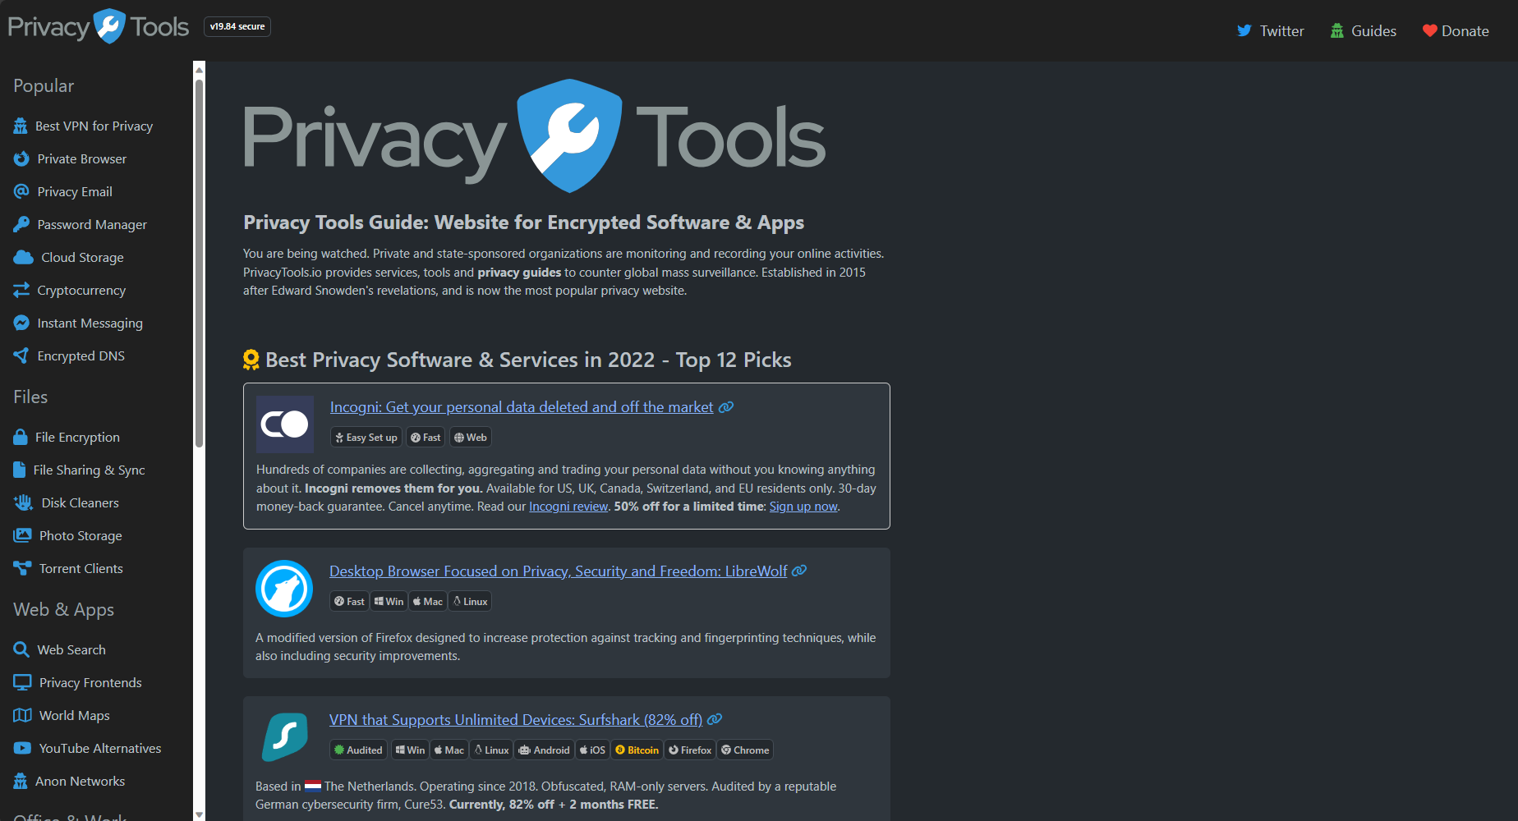

Best privacy software and services classified by PrivacyTools in 2022 –

* + - 1. **Whonix:** Full Operating System That Runs Inside Your Current One with Tor. It runs inside your current operating system and is effortless to set up, even for complete beginners. All your internet traffic gets automatically routed through the Tor network.

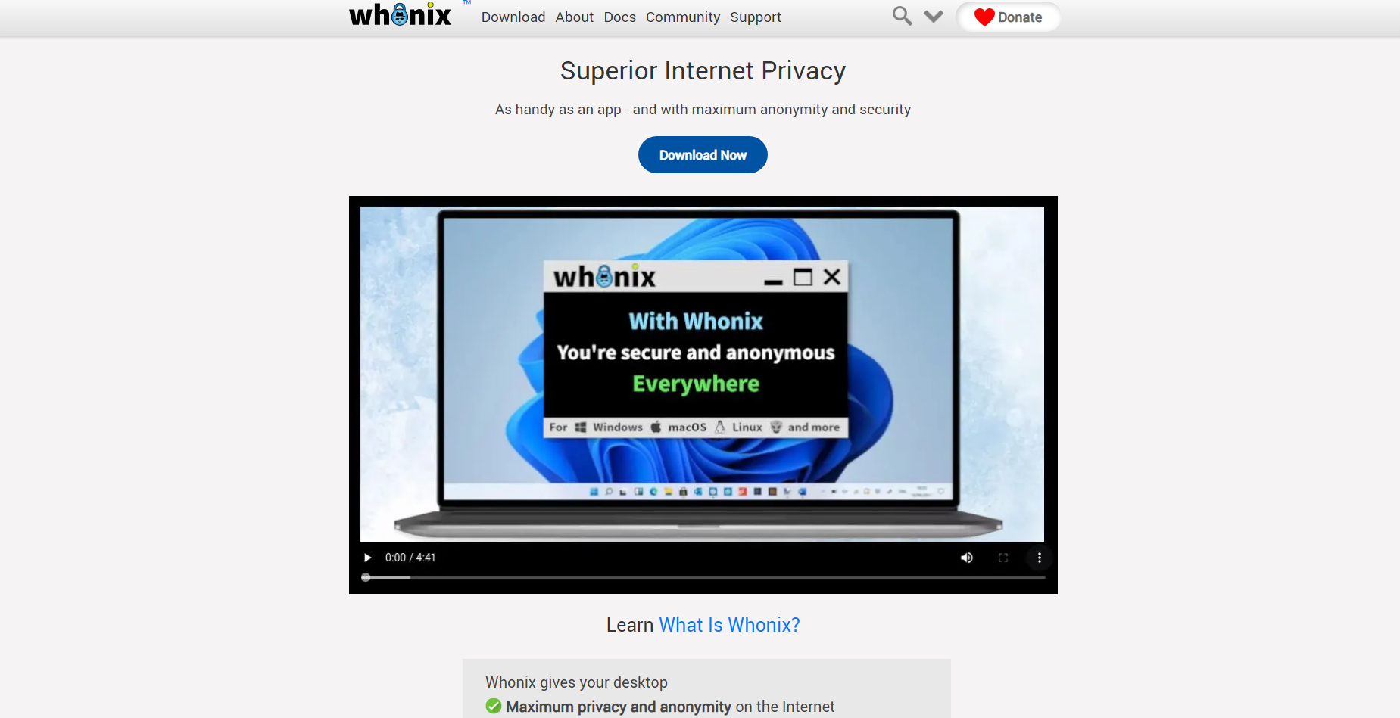

* + - 1. **LibreWolf:** Desktop Browser Focused on Privacy, Security and Freedom. A modified version of Firefox designed to increase protection against tracking and fingerprinting techniques, while also including security improvements.

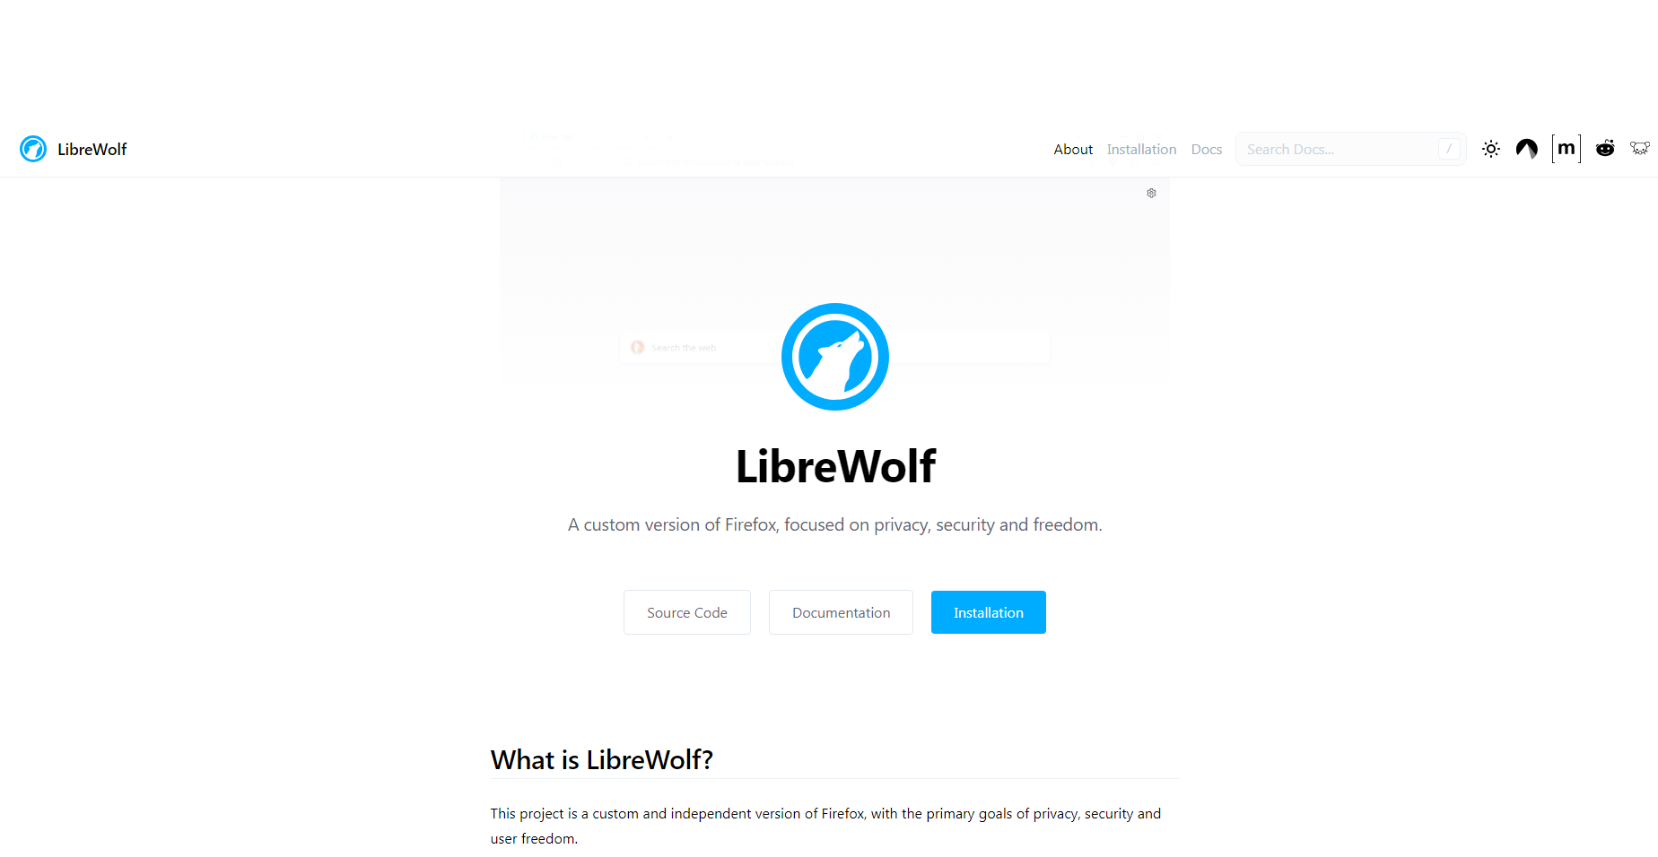

* + - 1. **Skiff:** Encrypted Mail, Notes, Calendar and Drive. Gmail & Workspace Alternative with Encrypted and Decentralized IPFS Storage. Modern, feature rich and user-friendly user interface. The free plan offers 10 GB storage and unlimited bandwidth. Premium plans are fairly priced in a range from $3 with 15 GB, $8 with 200 GB and $12 for 1 TB storage, monthly cost via annual payment. Custom domains and aliases are also available, even with a free plan. Accepted crypto payment methods: Bitcoin, Ethereum and USDC. Audited by a reputable cybersecurity firm, Trail of Bits.

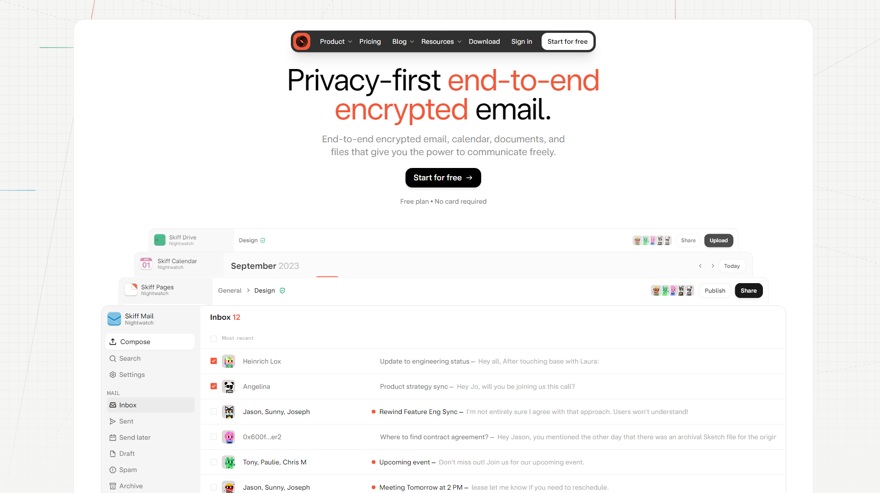

# Scope and Limitations

PrivacyTools.io provides a wide range of resources, recommendations, and guides related to online privacy. It covers various aspects such as web browsing, email providers, messaging apps, VPNs, password managers, encryption techniques, and more. The platform caters to both average internet users seeking basic privacy protection and tech-savvy individuals looking for advanced security measures.

While PrivacyTools offers extensive information on privacy tools and services, it does not guarantee absolute security or anonymity. Users should understand that no system is entirely foolproof against determined adversaries. The website's recommendations may not always align with individual preferences or specific needs. Users are encouraged to carefully evaluate the suggested options before making decisions based on their unique circumstances. PrivacyTools primarily focuses on software solutions rather than addressing broader societal challenges related to surveillance laws or data collection practices by governments and corporations. As technology evolves rapidly, some of the recommended tools or services listed on PrivacyTools may become outdated over time. Users should stay vigilant about staying updated with the latest developments in digital privacy protection.

# Conclusion

PrivacyTools is a highly valuable online resource that empowers individuals to take control of their digital privacy. By providing a curated collection of privacy-focused tools, services, and educational content, the platform equips users with the knowledge and resources needed to protect their personal data from surveillance and invasive tracking practices. Despite its limitations in addressing broader societal challenges related to surveillance laws or staying up-to-date with rapidly evolving technology, PrivacyTools.io serves as an invaluable tool for both average internet users seeking basic privacy protection and tech-savvy individuals looking for advanced security measures.

# References

* <https://www.privacytools.io>